3. WATER JUG PROBLEM

Aim:
To develop a Python program to solve the Water Jug Problem and obtain the required quantity of water using two water jugs.

Objective :
- To understand the Water Jug Problem.
- To simulate the filling, emptying, and transferring of water between two jugs.
- To obtain the required target quantity of water.
- To display each intermediate state until the target is reached.

Algorithm:
- Start.
- Define the capacities of Jug 1 and Jug 2.
- Specify the target quantity of water.
- Initially, both jugs are empty.
- Repeat until the target quantity is obtained:
- If Jug 1 is empty, fill it completely.
- Else if Jug 2 is full, empty Jug 2.
- Otherwise, pour water from Jug 1 into Jug 2 until Jug 2 is full or Jug 1 becomes empty.
- Display the amount of water in both jugs after every operation.
- When the target quantity is obtained, display the success message.
- Stop.

Flowchart :

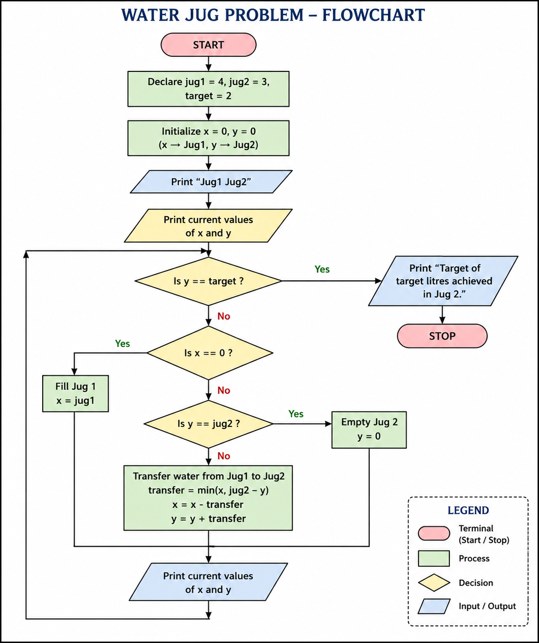

Code:
jug1 = 4
jug2 = 3
target = 2
x = 0
y = 0
print("Jug1 Jug2")
while y != target:
if x == 0:
x = jug1
elif y == jug2:
y = 0
else:
transfer = min(x, jug2 - y)
x -= transfer
y += transfer
print(x, " ", y)
print("\nTarget of", target, "litres achieved in Jug 2.")

Output:

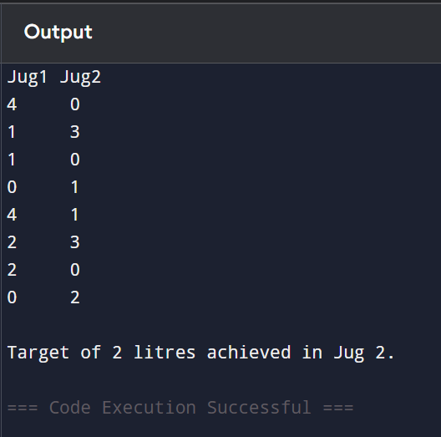
Result :
The Water Jug Problem was successfully implemented using Python. The program simulated the operations of filling, emptying, and transferring water between two jugs until the required target quantity of 2 litres was obtained successfully.

